**Company Database Query 1 to 11**

1. **Display all the details of all employees working in the company**

**select * from employee;**

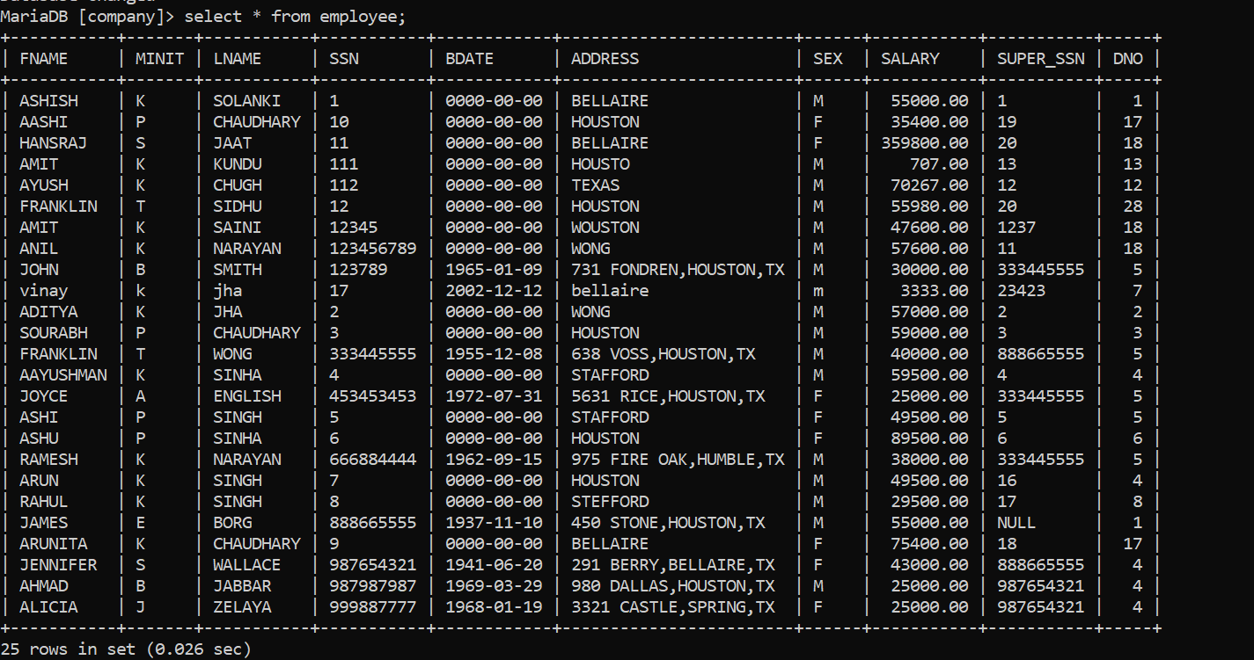

1. **Display ssn, lname, fname, address of employees who work in department no 7**

**select ssn,lname,fname,address from employee where dno=7;**

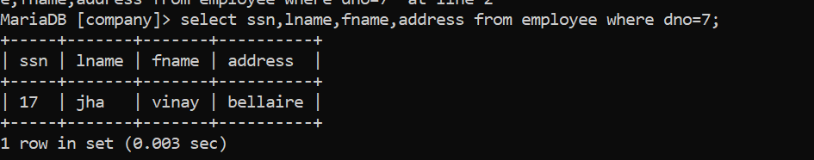

1. **Retrieve the birthdate and address of the employee whose name is 'Franklin T.**

select bdate,address from employee where fname='franklin' and minit='t';

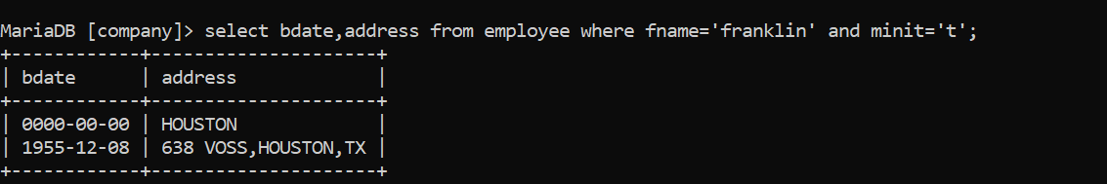

1. **Retrieve the name and salary of every employee.**

select fname,minit,lname,salary from employee;

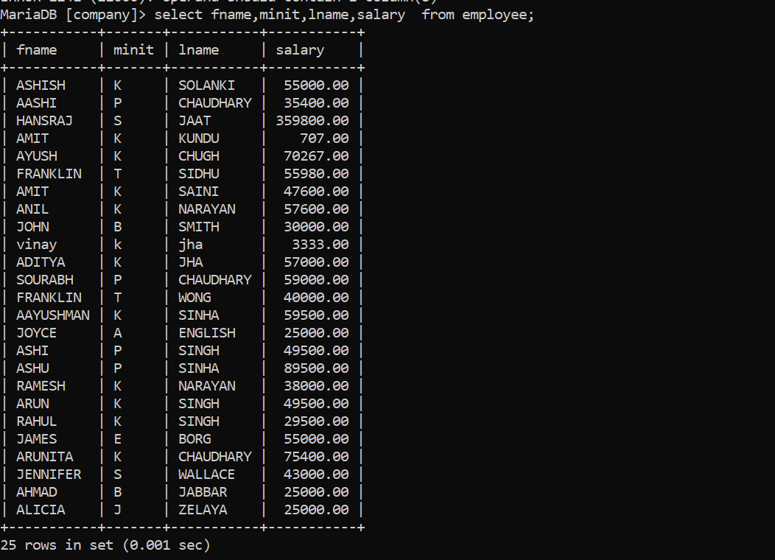

1. Retrieve all distinct salary values

select distinct salary from employee;

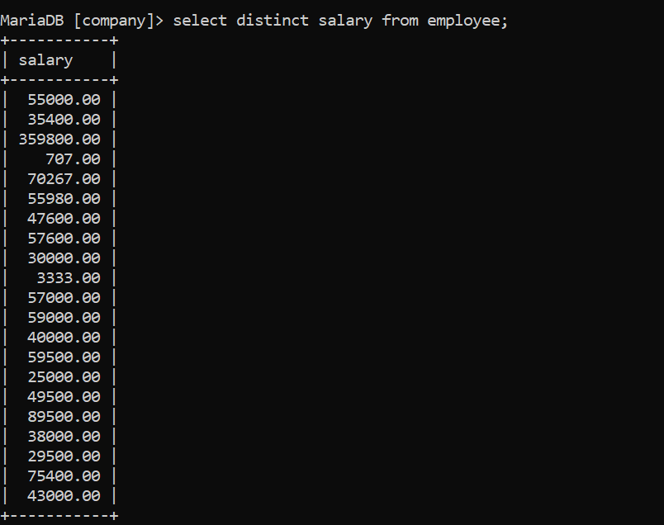

1. **Retrieve all employee names whose address is in ‘Bellaire’ Wong'**

select fname,minit,lname,address from employee where address like'%bellaire%' or address like'%wong%';

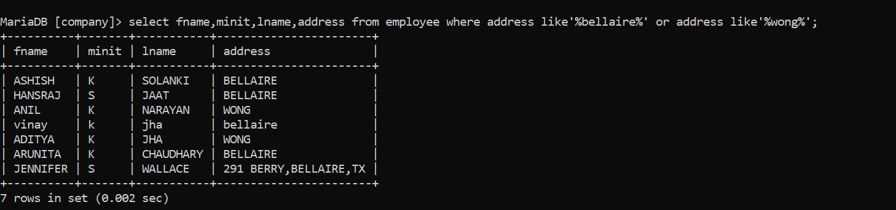

1. **Retrieve all employees who were born during the 1950s**

**select fname,minit,lname from employee where bdate between '1950-01-01' and '1959-12-31';**

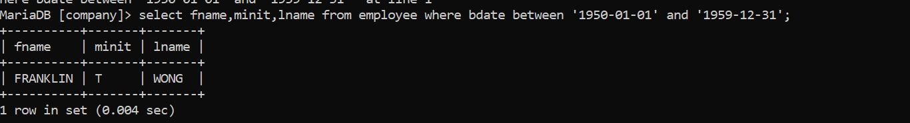

1. **Retrieve all employees in department 5 whose salary is between 50,000 and 60,000(inclusive)**

select fname,minit,lname from employee where dno=5 and salary between 50000 and 60000;

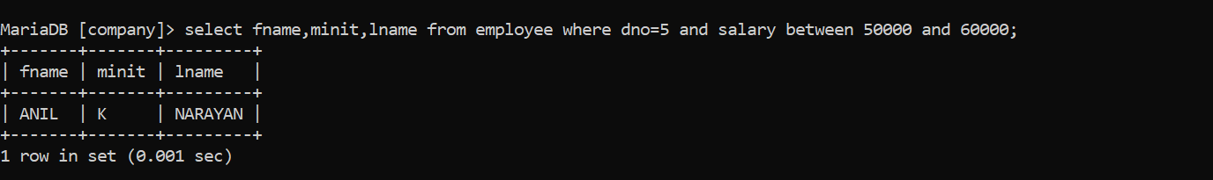

1. **Retrieve the names of all employees who do not have supervisors**

select fname,minit,lname from employee where super_ssn is null;

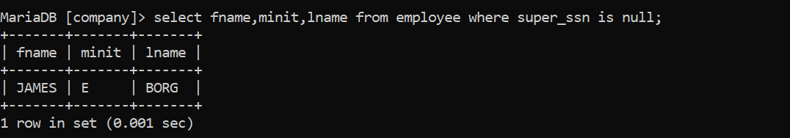

1. **Retrieve SSN and department name for all employees**

select ssn,dname from employee,department where dno=dnumber;

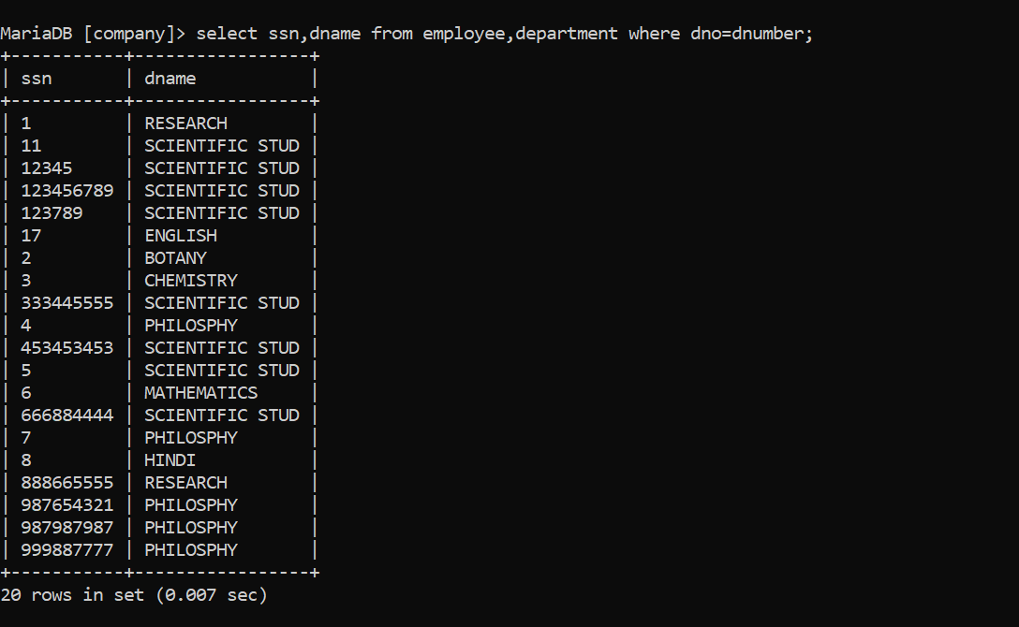

**11.Retrieve the name and address of all employees who work for the 'Research' department.**

select fname,minit,lname,address from employee,department where dname='research' and dno=dnumber;

